

**Automated Software Testing Fundamentals**

**(L/617/8670)**

**Learner Assessment  
Booklet**

**Learner Assessment Booklet**

**Level 4 Diploma in Software Testing**

**Unit:** Automated Software Testing Fundamentals

**Credit Value:** 16

**Unit Reference Number:** (L/617/8670)

***This form is used to record and confirm that assessment has taken place and the learner has achieved the unit detailed on pages 5 & 6***

|  |  |
| --- | --- |
| **Learner Name:** | Ryan McKee |
| **Assessor name:** |  |
| **Internal Verifier name:** |  |
| **Course:** |  |
| **Course code:** |  |
| **Completion Date:** |  |

|  |
| --- |
| **Achievement of unit is confirmed: Yes/No**  **Signature of Assessor:**  **Date:** |

|  |
| --- |
| **I certify that all the work in this booklet is my own.**  **Learner Signature: Ryan McKee**  **Date: 30/04/2023** |

**Assessment Grid: *Completed by Assessor***

|  |  |  |  |  |  |
| --- | --- | --- | --- | --- | --- |
| **Learning Outcomes** | **Achieved**  **(Delete)** | **Criteria** | **Booklet Page** | **Assessment Date**  **(If Applicable)** | **Date of Verification**  **(If Applicable)** |
| **1** | Yes | 1.1  1.2 | **7**  **8** |  |  |
| **2** | Yes/No | 2.1  2.2  2.3 | **9**  **10**  **11** |  |  |
| **3** | Yes/No | 3.1  3.2  3.3  3.4  3.5 | **13**  **17**  **20**  **23**  **25** |  |  |
| **4** | Yes/No | 4.1  4.2  4.3 | **26**  **27**  **30** |  |  |
| **5** | Yes/No | 5.1  5.2  5.3 | **31**  **32**  **35** |  |  |
| **6** | Yes | 6.1  6.2 | **37**  **38** |  |  |
| **7** | Yes/No | 7.1  7.2 | **41**  **43** |  |  |

***Note to Assessors:***

***This assessment record book is a template that you may choose to use to record summative assessment activities. It is intended to offer a framework for recording summative assessment. It is not intended to be prescriptive about assessment tasks. Assessors should amend the assessments and the booklet accordingly, taking account of the needs of their specific learner group and any opportunities for using combined assessments that cover multiple assessment criteria or learning outcomes.***

**Assessment record: *Completed by Assessor***

|  |
| --- |
| **Assessor Assessment decisions:** |

**Signature of Assessor:**

**Date:**

**All the following Learning Outcomes and Assessment Criteria MUST be met:**

**This unit has seven learning outcomes**

|  |  |
| --- | --- |
| **Learning Outcomes** | **Assessment Criteria** |
| **The learner will:** | **The learner can:** |
| 1. Understand what is meant by automated testing and its application. | * 1. Explain what is meant by test automation and the main two testing disciplines   2. Analyse at least three different features of web applications for which automated testing would be the optimal approach. |
| 1. Be able to research test automation practices in order to develop a software testing plan. | * 1. Research the advantages and disadvantages for test automation practices and their associated resources.   2. Critically compare the application of manual and automated software testing for a given application.   3. Develop an optimal software testing plan |
| 1. Be able to set up and use a web-based automated software testing tool. | * 1. Explain the setup procedures for using a web-based automated software-testing tool. – do this   2. Explain Hyper Text Transfer Protocol (HTTP) and its ability to retrieve appropriate resources.   3. Explain and demonstrate the use of at least four methods to assist the testing process available within a given testing tool. POST, PUT UPDATE AND DELETE screenshot the code for each of these and explain a bit about them.   4. Demonstrate the use of conditions to check for validity of tests   5. Demonstrate the effective use of a wait to assist with confirmation that a specific testing task has been successful. |

|  |  |
| --- | --- |
| **Learning Outcomes** | **Assessment Criteria** |
| **The learner will:** | **The learner can:** |
| 1. Be able to locate and test web elements. | * 1. Explain and demonstrate at least three different techniques to reference web elements on a webpage.   2. Explain what is meant by the Document Object Model (DOM) and how it allows a Hypertext Markup Language (HTML) webpage to be accessed.   3. Demonstrate the use of browser developer tools for testing. |
| 1. Be able to manage and interact with notifications within a browser. | * 1. Critically evaluate different types of notifications and responses received from interactions within a browser.   2. Summarise common exceptions and codes generated through different test actions   3. Use an appropriate test strategy to effectively manage and interact with a new tab or window. |
| 1. Be able to research and create a test automation suite.   “ A test suite is just several different classes testing classes within a software solution “ | * 1. Research and evaluate the advantages and disadvantages of implementing a test suite.   2. Create a test automation suite for use with multiple test cases for test execution purposes. |
| 1. Be able to research and create a test automation framework. | * 1. Research and evaluate the advantages and disadvantages of using a test automation framework.   2. Create a basic test automation framework for a given application that features reusability of code and low-cost maintenance. |

**ASSESSMENT CRITERIA (AC)**

**AC 1.1:** Explain what is meant by test automation and the main two testing disciplines.

Test automation refers to the use of software tools to execute tests automatically, without requiring manual intervention. Test automation is particularly useful for repetitive tests, where manual testing would be time-consuming and error prone. There are two main disciplines withing test automation the first being functional testing which involves testing whether the system or software application is functioning as expected, by verifying its behaviour against a set of predefined requirements. Functional testing includes testing individual functions or features of the system or software application, as well as testing the overall behaviour of the system examples of functional tests would be smoke testing, regression testing, integration testing unit testing, alpha and beta testing and user acceptance testing just to name a few.

The second method of automation testing is non-functional testing this is when non-functional aspects of the system or software application, such as performance, reliability, scalability and security. Are tested. Non-functional testing focuses on the systems’ ability to meet performance requirements, handle varying loads, and function effectively and securely in different environments. Some examples of non-functional tests include performance tests, load tests stress tests and security tests.

Overall test automation can be applied to both functional and non-functional testing disciplines. Automating tests can significantly reduce the time and effort required to perform tests, while also improved their accuracy and repeatability.

**AC 1.2:** Analyse at least three different features of web applications for which automated testing would be the optimal approach.

Automated testing has become an indispensable practice in modern web application development as it helps to ensure that software meets its requirements and operates as expected. There are several features of web applications where automated testing is optimal, including UI testing, API testing, and performance testing.

Automated UI testing is an optimal approach for web applications that have a large user interface, such as e-commerce sites, content management systems, and social media platforms. The user interface is a critical aspect of web applications as it's the primary way users interact with them. Automated UI testing frameworks, such as Selenium, can simulate user interactions and verify the expected output against the actual output. This can help to ensure that the application's interface is functioning as expected and is responsive to user interactions.

Web applications are often built using APIs, which expose data and functionality to other applications. Automated API testing is optimal for applications that rely heavily on APIs, such as those with complex data structures, multiple endpoints, or those that integrate with third-party APIs. Automated API testing can verify that the API endpoints return the expected response and that the response is correctly formatted. It can also ensure that the API performs as expected under varying loads and network conditions. Tools such as Postman or Newman can be used to automate API testing.

Web applications must perform well to provide a satisfactory user experience. Automated performance testing is optimal for web applications that have high traffic and a large user base, such as e-commerce sites, social media platforms, or video streaming services. Automated performance testing can help to ensure that the application can handle the expected load and is responsive under varying traffic and network conditions. Tools such as JMeter can be used to simulate traffic and measure performance metrics like response times, throughput, and error rates.

In conclusion, automated testing is essential for ensuring the quality and performance of web applications. UI testing, API testing, and performance testing are three critical areas where automated testing can be an optimal approach to achieving quality and reliability in web application development. By incorporating automated testing into the development process, web developers can minimize the risk of errors and ensure that their applications meet user requirements and provide a satisfactory user experience.

**Section 2**

**AC 2.1:** Research the advantages and disadvantages for test automation practices and their associated resources

Test automation is the use of software tools to perform testing tasks automatically, without requiring human intervention. The advantages of test automation include faster and more efficient testing, increased test coverage, and the ability to run tests repeatedly with little or no additional cost. Additionally, test automation can detect defects earlier in the development process, reducing the overall cost of fixing defects and enhancing the quality of the software product.

On the other hand, test automation also has some disadvantages. Initial setup and configuration of the automation tools can be time-consuming and costly. Maintenance of test scripts and automation frameworks can also be challenging and require continuous effort. Test automation cannot completely replace manual testing, as some aspects of testing still require human intelligence and creativity. Finally, the return on investment for test automation needs to be carefully evaluated to ensure that the benefits of automation outweigh the costs.

In terms of specific tools, TestNG is a testing framework that provides features such as grouping, sequencing, and parallel execution of test cases. Rest Assured is a Java library used to test RESTful web services. Selenium is an open-source tool used to automate web browsers for testing web applications. Each tool has its own advantages and disadvantages, and the selection of a particular tool depends on the specific requirements of the project and the expertise of the testing team.

Overall, test automation can be a valuable addition to a testing process, but it should not be viewed as a complete replacement for manual testing. It is important to carefully evaluate the benefits and costs of automation, select appropriate automation tools, and ensure that the testing team has the necessary skills and expertise to effectively use the automation tools.

**AC 2.2:** Critically compare the application of manual and automated software testing for a given application

The Staff API is a REST API application that includes endpoints for push, put, delete, and get operations. In order to ensure its reliability and scalability, testing is essential. Manual testing and automated testing are two approaches that can be used to test the Staff API, each with its own advantages and disadvantages.

Manual testing involves a tester manually interacting with the application by sending requests to the API endpoints and checking the responses. This approach offers more flexibility and adaptability in testing, as testers can easily change test cases and provide a more subjective evaluation of the application. However, manual testing is time-consuming, error-prone, and expensive since it requires human effort.

On the other hand, automated testing involves using tools to automate the testing process. Tools like Postman, Rest Assured, and TestNG can be used to create and execute automated tests. Automated testing is faster, more reliable, and less error-prone than manual testing. Additionally, it is useful for repetitive testing tasks and can easily be integrated with Continuous Integration and Continuous Delivery pipelines, making code maintainable and expandable. However, automated testing requires a higher initial investment in terms of setup and tooling, and can only be as effective as the test cases it is built upon.

Both manual and automated testing can be useful for different purposes in testing the Staff API. Manual testing is particularly useful for exploratory testing, usability testing, and testing of edge cases. On the other hand, automated testing is particularly useful for regression testing, where the same test cases are repeatedly executed to ensure that changes made to the API did not introduce new errors or regressions. It is also useful for load testing, where multiple requests are sent simultaneously to test the performance and scalability of the API.

Both manual and automated testing can be applied to specific endpoints. For instance, automated tests can be created for the "get-all-staff" endpoint to verify that the list contains the expected number of staff members. Similarly, for the "add-new-staff-member" or "update-staff" endpoints that add or update staff information, automated tests can be created to verify that the data has been updated as expected. For the "delete-staff-member" endpoint, a test can be written to verify that the management record number has been reduced by 1 and that the correct staff member was deleted.

In conclusion, both manual and automated testing have their own advantages and disadvantages, and they can be applied to all the endpoints within the staff-API system. However, based on the current needs of the system, automated testing is the best approach to ensuring reliability and scalability into the future. This is because there are no complex endpoints that require user authentication, involve complex business logic or interact with external systems of dependencies. Automated testing is faster, more reliable, and less error-prone, making it the ideal approach for testing the Staff API.

**AC 2.3:** Develop an optimal software testing plan

**Section 3**

**AC 3.1:** Explain the setup procedures for using a web-based automated software-testing tool

This step involves creating a new Maven project, which is relatively simple to accomplish in most IDEs. A Maven project provides a structured and standardized approach to software development and is widely used in Java-based web applications.

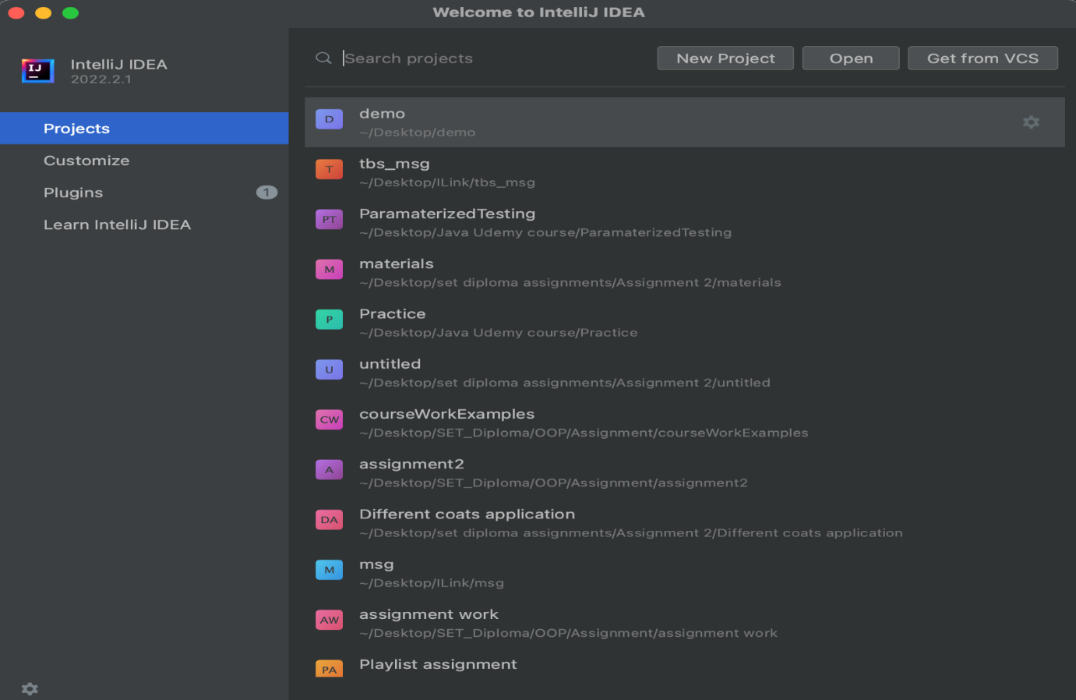

Input the name of your testing application, select the JDK version, and choose the appropriate Archetype from the available templates. 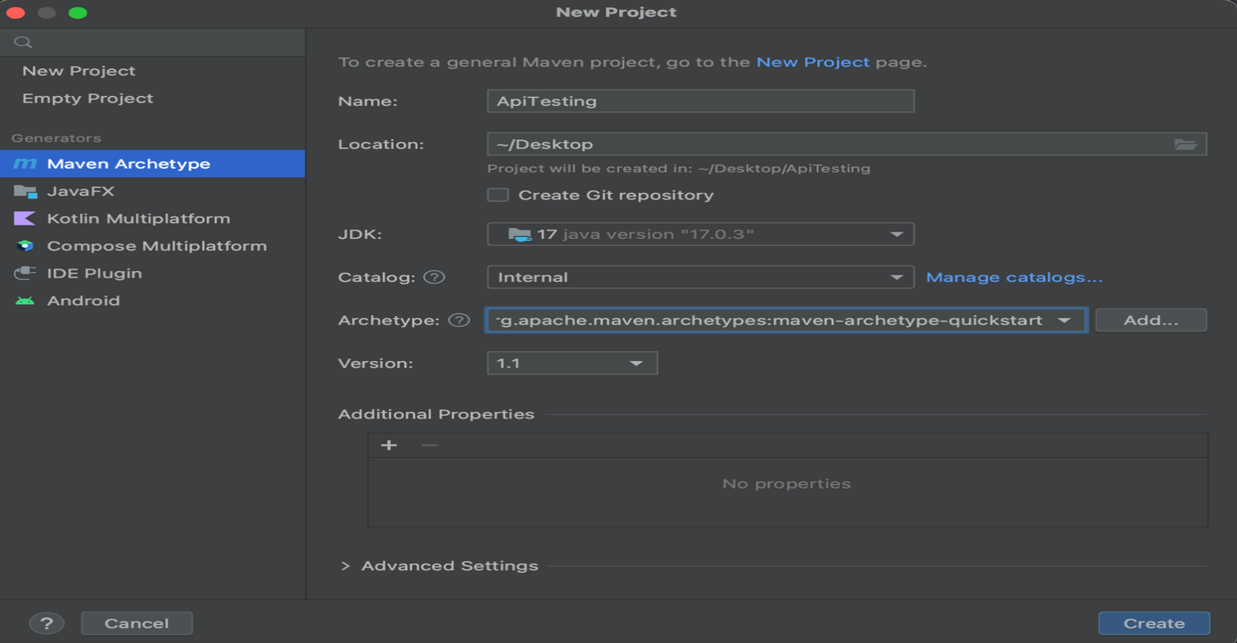In this step, you will specify the name of your testing application and select the version of the Java Development Kit (JDK) you wish to use. Additionally, you will choose an Archetype, which is a collection of pre-defined templates that provide a starting point for your project. This selection determines the structure and dependencies of your project. Ensure that you choose the appropriate Archetype that suits your project requirements.

Once you have completed Step 2, your project will open up, and Maven will automatically begin generating the project based on the templates defined in the pom.xml file.

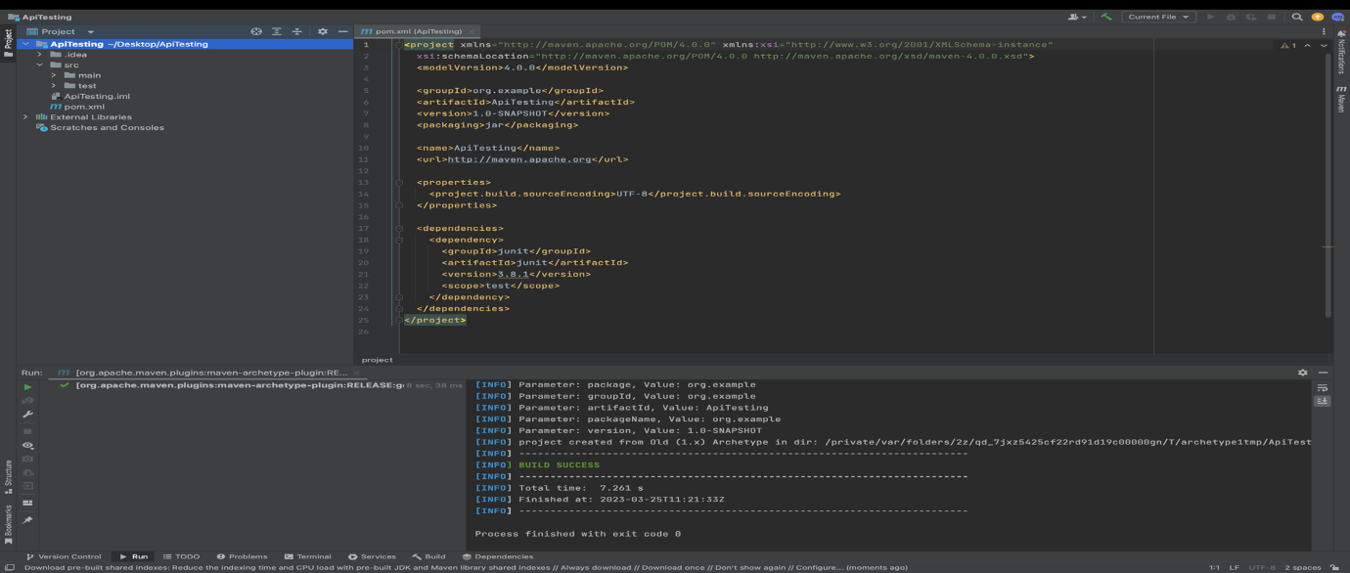At this point, the project structure and dependencies are defined, and Maven is configuring the project based on the selected Archetype. The pom.xml file is a configuration file that defines the project's build process, dependencies, and other details. Maven uses this file to manage the project's build and deployment process. With the project generation underway, proceed to the next step.

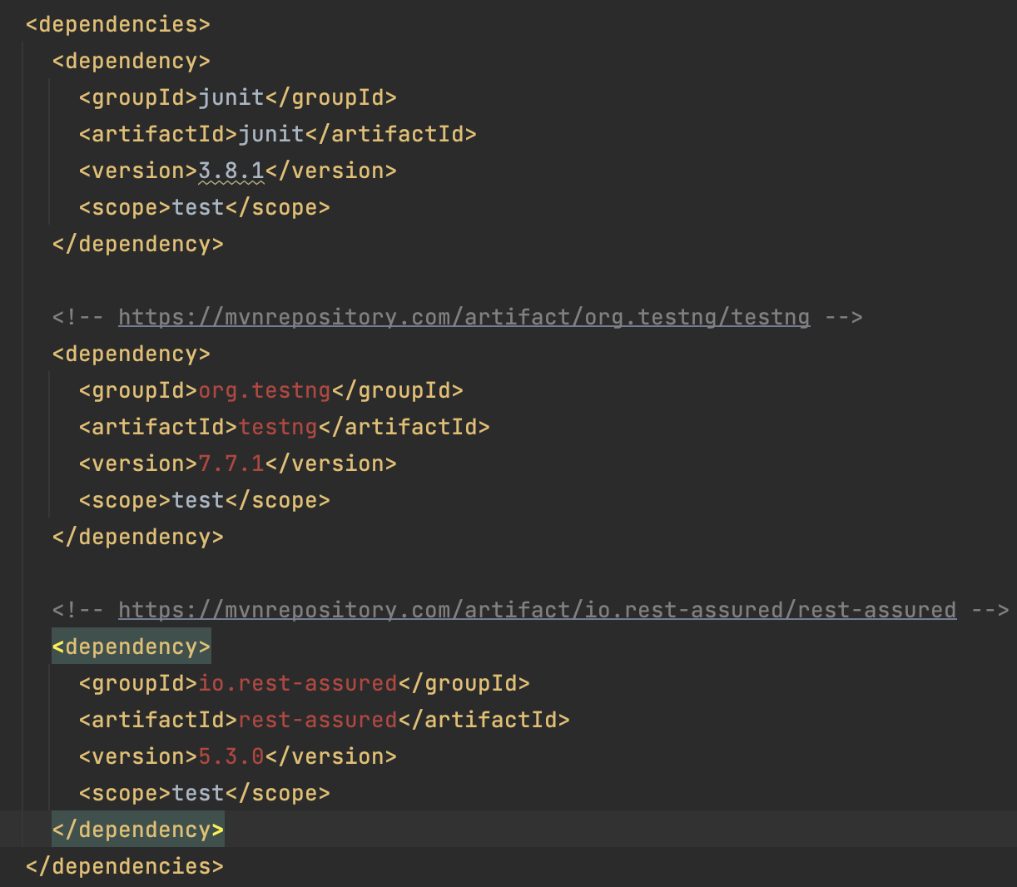In this step, you will add import statements for the libraries required by your test automation project to the dependencies section of the pom.xml file. These libraries include Rest Assured and TestNG, which are essential for implementing automated tests in web applications. By adding these libraries to the project, you can leverage their functionality in your test scripts. Ensure that the import statements are correctly formatted and located within the dependencies section of the pom.xml file.

Click install and maven will install these new project dependencies.

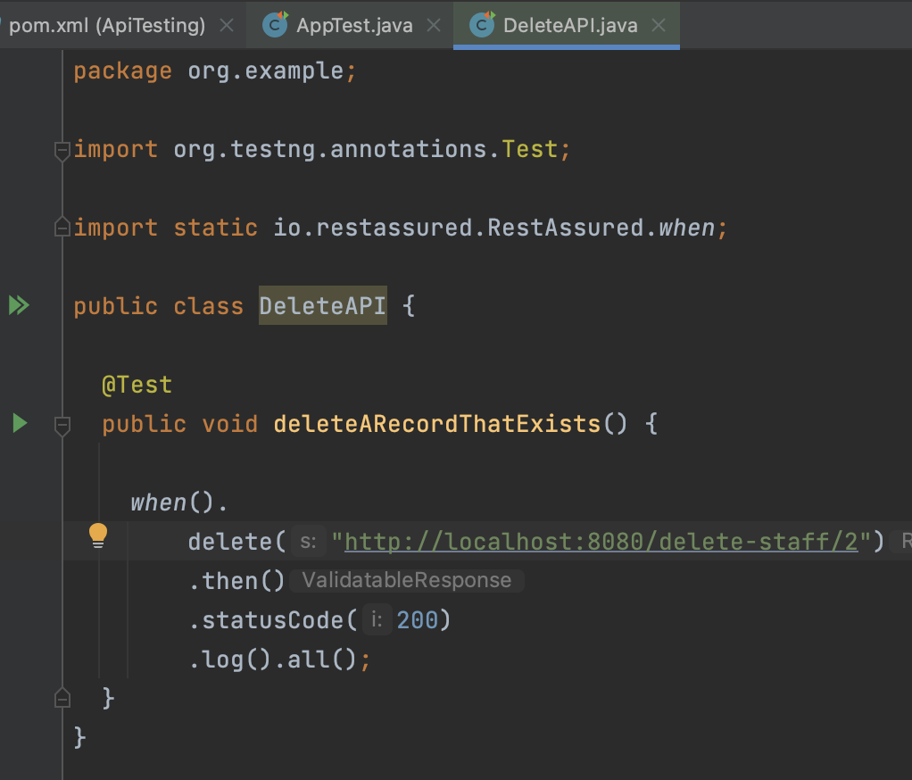With the project dependencies in place, you can now create your API test. Below is an example of a Rest Assured test that checks the response when a delete function occurs on the localhost.

**AC 3.2:** Explain Hyper Text Transfer Protocol (HTTP) and its ability to retrieve appropriate resources.

Hyper test transfer protocol (HTTP) is a protocol used for communication between web servers and clients, such as web browsers. The HTTP protocol governs how requests from clients are made to the server, and how the server responds to those requests with the appropriate resources like HTML pages, images, documents videos and audio files and web services.

HTTP uses uniform resource locators (URLs) to identify resources on the web. A URL is a unique address that identifies a resource such as a web page, image or document. The URL consists of a protocol (http:// or https://), a domain name example.com which will translate to the physical address e.g. 198.102.434.8 and a path to the resource on the server e.g. ( /documents/foo )

HTTP requests can be made using several different methods. The most common HTTP methods are GET, POST, PUT or DELETE.

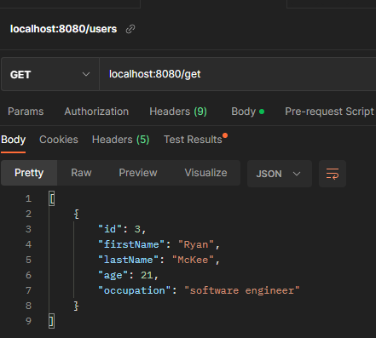**Get:** This method is used to retrieve a resource from the server. When a client sends a GET request to a server, the server response by sending the requested resource back to the client. GET requests can be cached by clients and servers, making them useful for retrieving resources that do not change frequently.

Figure : The image on the left shows an example of a get request for a localhost server which gets a staffs details. The resource is returned in JSON format.

**POST:** This method is used to submit data to the server. When a client sends a POST request to a server, it typically includes data in the request body that the server can use to perform some action, such as updating a database. Post requests are not cached by clients of servers, making them useful for submitting data that should not be cached.

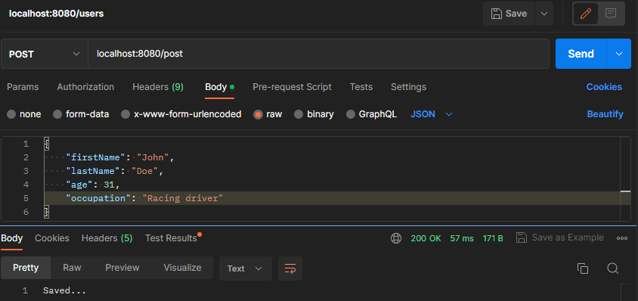

Figure : Above shows an example of a POST request. When endpoint /post is used the information in json format in the request body is sent to the server this is confirmed by the response body at the bottom returning the string saved and the status code 200 on the bottom right in green.

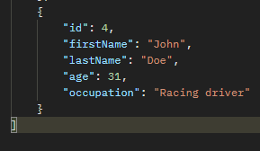PUT: This method is used to update an existing resource on the server. When a client sends a PUT request to a server, it typically includes the updated data in the request body, and the server updates the resource with the new data. PUT requests can be used to create new resources as well, if the server supports this.

Above shows the record with id 4 before the PUT operation was performed.

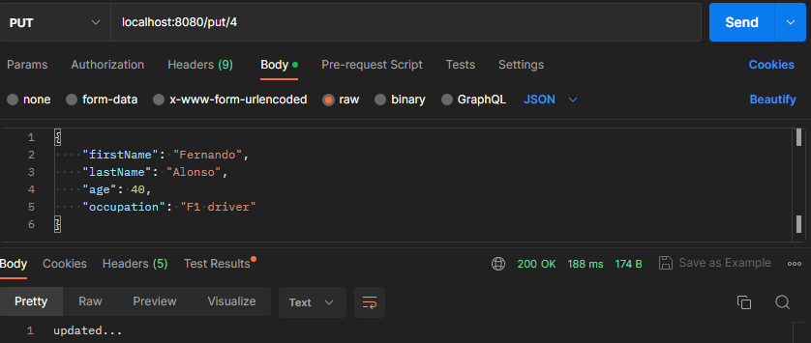

Figure : Above shows and example of the end point put which also takes the id of the record that is being updated. In this example the record with id 4 is updated to contain the information sent in the message body. Below shows the output of that PUT request which was received from the response body.

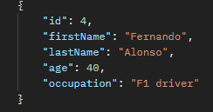

**DELETE:** This method is used to delete a resource from the server. When a client sends a DELETE request to a server, the server deletes the resource and responds with a confirmation message. DELETE requests can be used to remove resources that are no longer needed.

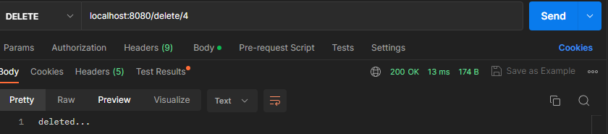

Figure : Above shows an example of the delete end point it takes a path variable and as long as there is a record in the database with this id the record will be deleted as shown in the example above.

In summary, HTTP is a protocol that allows clients and servers to communicate and exchange resources. HTTP request can be made using different methods (verbs) such as GET, POST, PUT, and DELETE, each serving a different purpose in retrieving and manipulating resources on the server.

**AC 3.3:** Explain and demonstrate the use of at least four methods to assist the testing process available within a given testing tool.

When testing an API, it is crucial to create a test suite that covers all its functionalities. We can automate these tests using TestNG as the testing library and Rest Assured, which provides a DSL for testing RESTful APIs like the one in the example. Rest Assured allows for tests to be written in a simple and readable manner, making it easier to validate the API's functionality. It is a Java library that offers a DSL specifically for testing RESTful APIs.

**GET test**

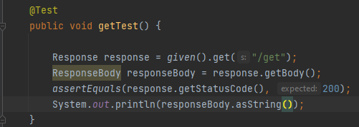

Figure : Above is a GET test that checks if the /get endpoint returns a status code of 200, indicating that the request was successfully received, understood, and accepted by the server. This means that the server has processed the request and is returning the requested information to the client in the message body of the response. To ensure that the response body is not null, the test prints it to the console manually.

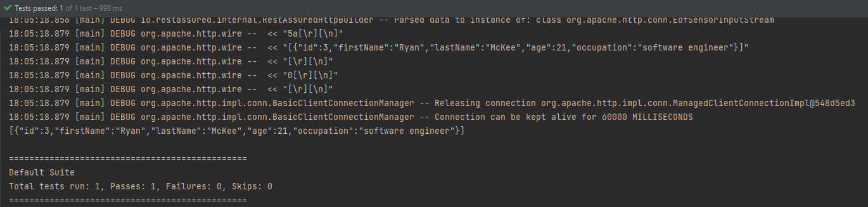

Figure 6: Above is the console output after running the getTest. It displays the returned response body and confirms that the test has passed.

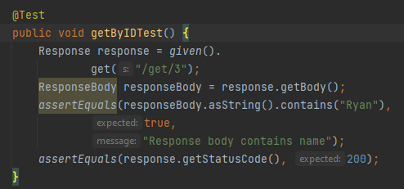

Figure : Above is another example of a GET request, this time using a different endpoint that takes a specific ID of a staff member (in this case, number 3). The test checks if the response body contains "Ryan" (to confirm that this is the expected staff member) and if the status code is 200, indicating a successful response.

**PUT test**

Figure : This is an example of a PUT test function. It checks if sending employee data in JSON format via the request body to the /update-staff/4 endpoint results in a successful request with a status code of 200.

**POST test**

Figure : This is an example of a POST REST test function. The function checks if, when using the /add-new-staff-member endpoint and passing an employee's details in JSON format in the request body, the response code is 200 and the size of the employee list has incremented by 1.

**DELETE TEST**

Figure : This code contains a unit test for the delete-member-endpoint. The test will fail if there are no records in the database, as it requires at least one record to be present. The test retrieves the ID of the last record in the database using a GET request, and then calls the delebeByIdAndGetResponse function to delete the record using this ID. It checks the response code to ensure that it is 200, indicating that the delete was successful, and also verifies that the database size has decreased by 1.

Figure : This function is used in the test function shown in Figure 7. It takes an ID as an argument and uses a REST Assured DELETE statement to call the “/delete-staff-member/” endpoint, with the ID given as a path parameter.

**AC 3.4:** Demonstrate the use of conditions to check for validity of tests

Conditionals provide a flexible and expressive approach to assert statements in automated tests. The Ham crest framework offers an extensive range of matchers that can be used in conjunction with unit testing libraries, such as TestNG, and mocking frameworks, such as Mockito. These matchers provide a powerful and intuitive way of writing assertions that are both expressive and concise, enabling developers to understand the test's objectives better.

Using Ham crest matchers has several benefits, one of which is the ability to create more robust tests that are less vulnerable to codebase changes. The matchers are designed to be highly reusable, allowing developers to test various scenarios and conditions while maintaining a test suite over time**.**

**examples:**

Figure : Above screenshot shows an example of matchers being used to assert that each of the response body values are equal to what is expected from the path parameter used: 1.

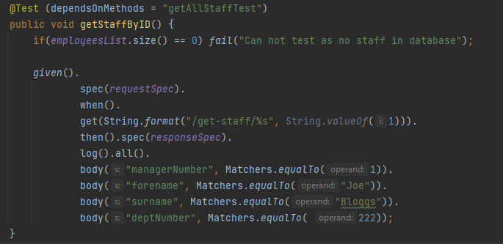**Matcher equal To**

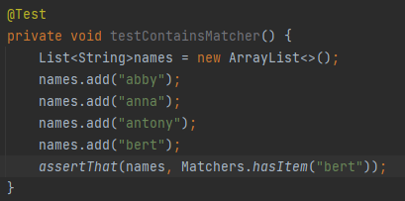**Matcher has Item**

Figure : Above is an example of the matcher has Item being used to assert that Bert exists in a list of names. Since it does this test will return true.

**Matcher contains string**

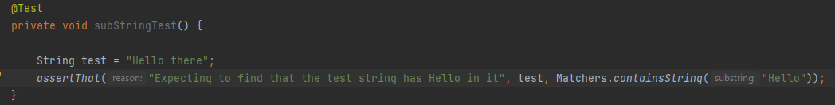

Figure : This shows an example of the Matcher.containsString in action. In this sample test it is checking if Hello is contained in Hello there which it is therefore making the test return true.

**Asserting that a value is greater than a given value.**

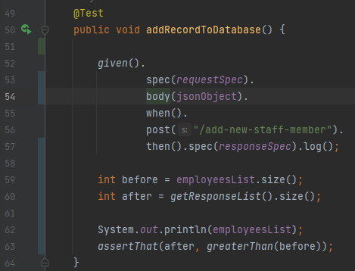

Figure : Line 63 on this code shows another example of a greater Than matcher. In this test this matcher is used to ascertain if the current records after an object have been posted to the spring API has increased by 1.

**AC 3.5 + 3.4:** Demonstrate the effective use of a wait to assist with confirmation that a specific testing task has been successful.

**The example below shows an example of a wait to assist. This wait to assist is a response time test this is used to measure the time taken by the spring boot API endpoints to respond to a request. This helps in assessing the performance of the API and identifying any potential bottlenecks or issues in the system. By monitoring the response time in these tests, the API can be assured to meet the performance requirements and can handle the expected loads. It also allows for identification of slow endpoints which can be further optimized to improve the overall system performance. In addition, response time can be used as a benchmark for future performance improvements and can provide valuable data for capacity planning and resource allocation.**

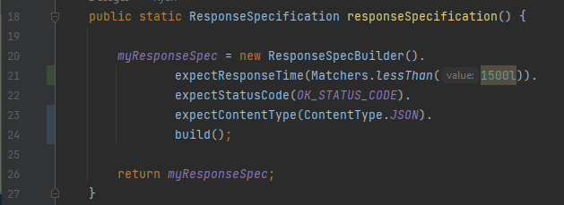

Figure : Line 21 on this code shows the code added for checking the response time is less that 1.5 seconds. This response specification static function is called in most of the API endpoint tests for ensuring that the response headers of these test responses to requests have the contain the expected values. This code further emphasises the use of matchers for testing as above I show that in the expectResponseTime function matcher less Than is used to ensure that the response time is less than 1.5 seconds.

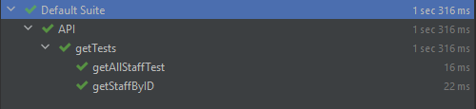

Figure : Above shows the outputs after the response time test is added on the right hand side of each of these tests. As all the tests meet optimal performance standards by taking under 1.5 seconds they all have passed.

**Section 4**

**AC 4.1:** Explain and demonstrate at least three different techniques to reference web elements on a webpage

Below contains a number of methods for locating and manipulating specific elements like buttons links and, forms and other interactive elements on a web page using unique identifiers.

Element ID

Referencing the element ID, a web automation tool or test script can easily interact with the targeted element, such as clicking a button, filling in a form field, or validating its content. This method is widely used approach in web automation and testing and is supported by most web automation frameworks and libraries like selenium.

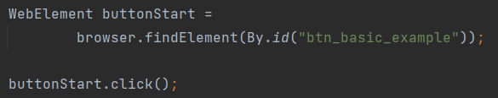

Tag names

This is a method of referencing a group of elements on a web page based on their HTML tag name. HTML tags are used to structure and define the content of a web page, and each tag has a specific purpose such as defining headings, paragraphs, lists and other elements This method is useful when the specific element ID or class is not available or when interacting with a group of elements that share the same characteristics. However, it may not be as precise as other methods since multiple elements can have the same tag name, and it may require additional filtering or validation to ensure the correct element is targeted.

XPath

Referencing a web element by XPath is a method of locating and manipulating specific web element on a web page using its XML path. XPath is a language used to query and navigate XML documents, including HTML pages, and can be used to locate specific elements based on their attributes, text content, or relative position within the HTML hierarchy. By using XPath expressions, a web automation tool or test script. XPath provides a powerful and flexible method for referencing web elements and is widely used in web automation and testing. However, XPath expressions can be complex and may require additional validation to ensure the correct element is targeted, and changes to the HTML structure may require updates to the XPath expressions.



**AC 4.2:** Explain what is meant by the Document Object Model (DOM) and how it allows a Hypertext Markup Language (HTML) webpage to be accessed.

The document object model is a programming interface for web documents that allows scripts to dynamically access and manipulate the content, structure, and style of a hypertext markup language (HTML) webpage. The DOM represents the webpage as a hierarchical tree structure of objects, where each element, attribute, and text node is represented as a node in the tree. The DOM provides a way for scripts to traverse and manipulate this tree structure, allowing them to interact with the webpage’s content and behaviour.

To access an HTML webpage using the DOM, a web browser loads the page and parses its HTML code to create a DOM tree that represents the page’s structure and content. The DOM tree can then be accessed and manipulated using JavaScript or other programming languages, allowing developers to modify the content, style and behaviour of the webpage dynamically. For example, a script can use the DOM to add and or remove elements, change the style of content of an element, or respond to user events such as clicks or keystrokes. The DOM provides a powerful and flexible way to interact with webpages and is widely used to web development and testing.

To access the document object model using a web browser you can use the browser’s built-in developer tools.

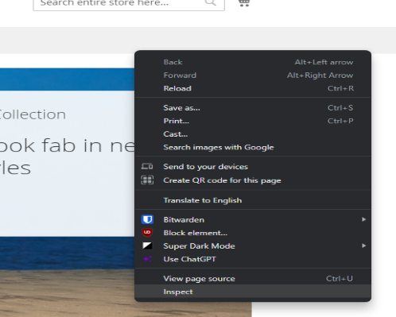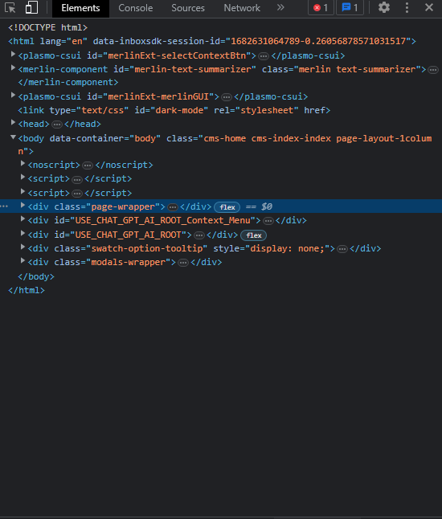To open the Document object model

Figure : Start by clicking on a webpage and selecting "inspect" form the context menu.

Figure : Then this element page will open up.

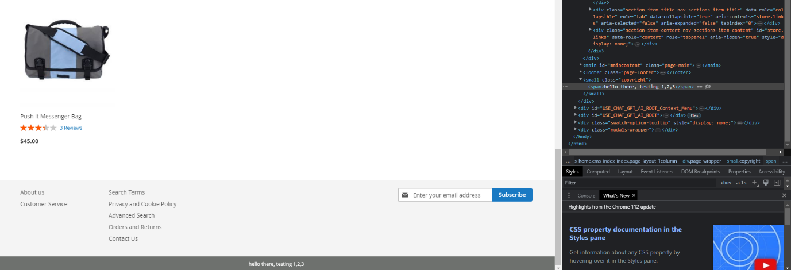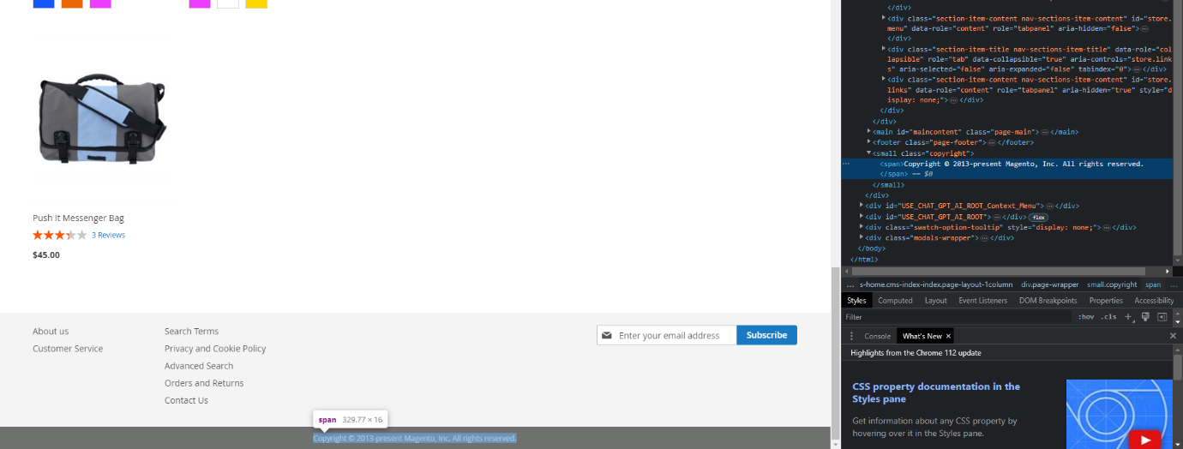Now within the DOM you can navigate and manipulate the DOM tree by selecting and editing elements in the elements panel.

Figure : This shows the DOM after the changes are made the copyright label and the changed text.

Figure : Below shows an example the DOM being expanded to show the properties of teh class copyrights text. Within here I change edit the text to show something else.

You can also utilize the DOM in order to write selenium tests for example If I wanted to write a test that would check if a webpage button took you to another web page, I would start by right clicking the button I am testing which will open a drop down, then clicking inspect which will open up the element properties

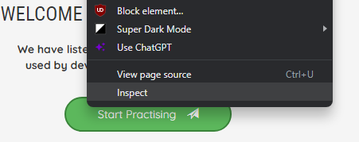

Within the DOM I can then retrieve information which will be used for the selenium test in this example we are going to use the button id shown in the highlighted region of the DOM file.

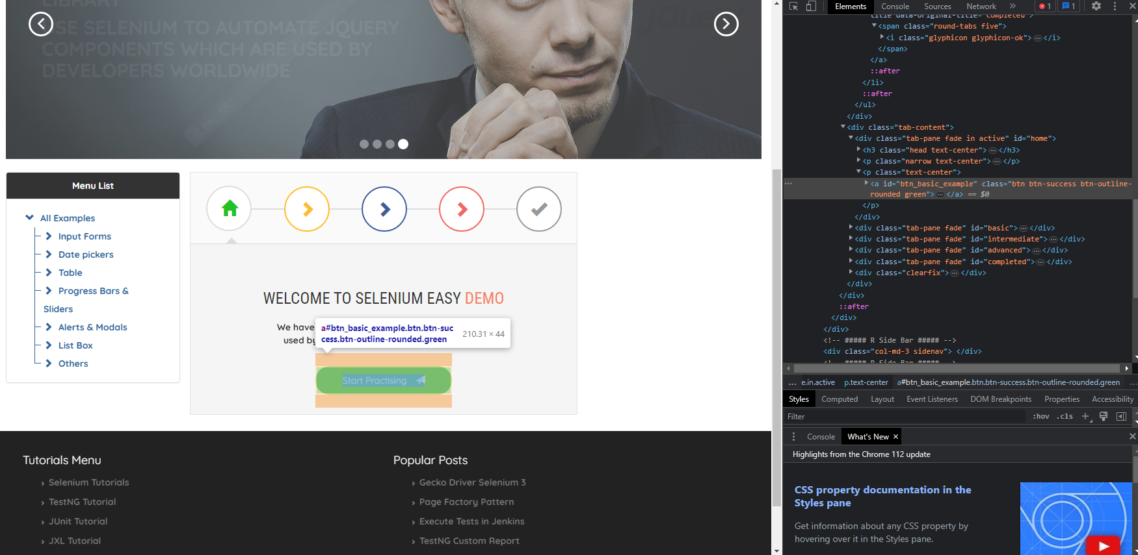

This button ID is then used within the test below in order to retrieve the element, Then the element Click () is used the transition is shown below.

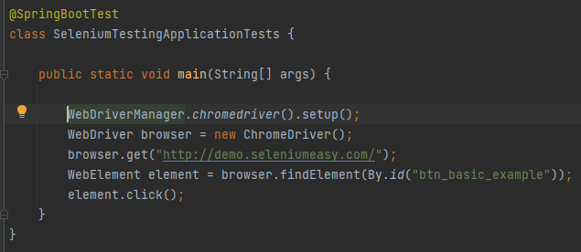

Figure : Selenium test using element ID retrieved from the DOM.

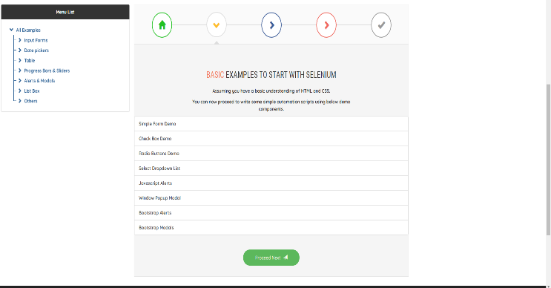

Figure : Web page at start of test.

Figure : Web page at end after web elements .click function was called.

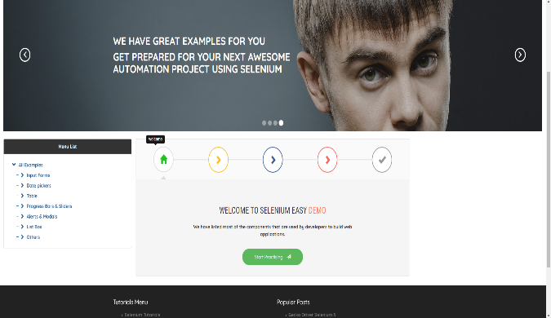

**A.C 4.3:** Demonstrate the use of browser developer tools for testing – need to show some examples of testing including screenshots**.**

Browser developer tools are essential for testing web applications. There are several tools that can be utilized to aid testing including Performance testing tools where you can use the performance tab to analyse the performance of your website, including page load times, resource loading, and network activity, Accessibility testing developer tools have built-in accessibility auditing tools that can be used to test the accessibility of your website, including checking for keyboard navigation and screen reader support. The developer tools allow you to inspect and manipulate the HTML and CSS of a web page. This can be useful for identifying layout issues, checking the box model, and testing responsive design. (An example of the browser developer tools being used to inspect the HTML is shown in the example shown in 3.2). Debug JavaScript: You can use the console to debug JavaScript code. This can be useful for identifying errors and testing the behaviour of your code and network analysis where You can use the network tab to analyse network traffic, including requests and responses. This can be useful for identifying slow loading resources and checking for errors in HTTP requests as well as seeing request and response information as shown in the example below.

Figure : Above shows the network developer tool for Chrome which is a built-in tool that allows developers to monitor the network activity of a web page. It provides information about the resources that are loaded, such as images, stylesheets and scripts. Under the network tabs left side it shows information about he get request made including the status code, type of method GET in this case the Domain and file as well as some additional information about file size. On the right hand side it shows additional information like the request and response header content types. There is several tabs you click the main ones being request and response which allows you to view the data passed in the request and response bodies.

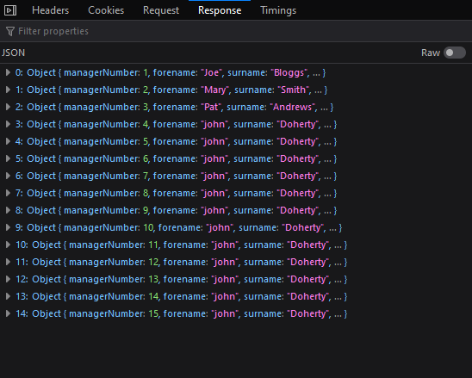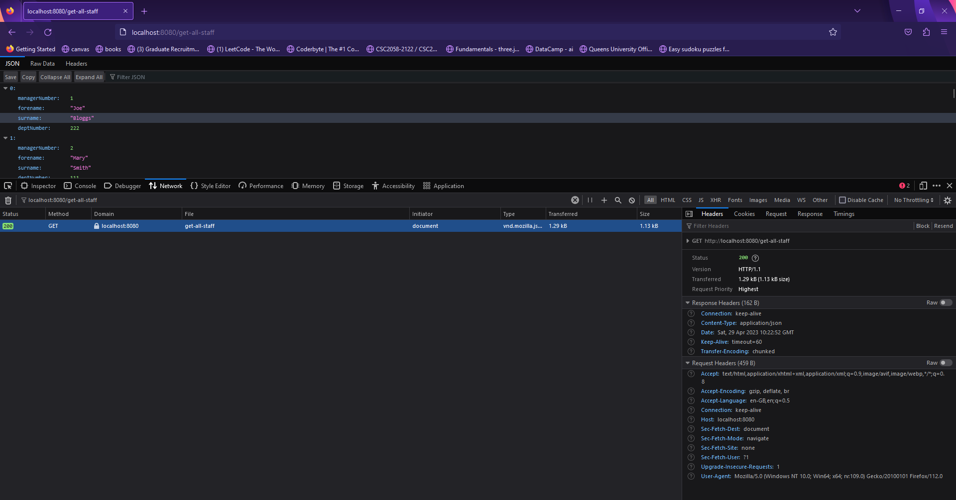

Figure : This figure shows the response body values returned from the get request being testing.

Overall browser developer tools are a powerful resource for testing web applications, and their many features can help developers ensure that their websites are running smoothly and efficiently.

**Section 5**

**AC 5.1:** Critically evaluate different types of notifications and responses received from interactions within a browser

Interacting with a web browser can generate various types of notifications and responses. Each type has its advantages and disadvantages. Pop-up notifications, for instance, are small windows that appear on the screen and provide users with important information or alerts. They are often used to prompt users to take certain actions or provide updates about their activities. While pop-up notifications are attention-grabbing and can quickly convey important information to users, they can also be annoying and disruptive, especially if they appear too frequently or interrupt the user's browsing experience. Moreover, pop-up blockers may prevent users from seeing these notifications altogether.

Toast notifications, on the other hand, are brief, unobtrusive messages that appear at the bottom or top of the screen. They are usually used to notify users about actions that have been completed, such as a successful login or a completed file upload. Toast notifications are less disruptive than pop-up notifications and can still convey important information to users. However, they can be easily missed if the user is not paying attention or if they disappear too quickly. Browser alerts are notifications that are built into the browser itself, rather than being generated by a website. These alerts are often used to warn users about potential security risks, such as when they are about to download a file from an untrusted source. The advantage of browser alerts is that they are highly reliable and difficult to ignore. However, they can also be overly cautious and may generate false positives, leading to frustration and annoyance for users. Error messages are notifications that appear when something goes wrong with a website or application. They can provide users with information about what went wrong and how to fix it. The advantage of error messages is that they can help users troubleshoot problems and recover from errors. However, they can also be confusing and frustrating if they are too technical or if they do not provide enough information to help users understand. When web-related errors occur, status codes are returned as responses to reflect these errors. Some websites and applications have error handling to provide clear information about what happened when this error occurred. However, some don't and will just show the response code. Without technical knowledge, the meaning of these codes means nothing.

In conclusion, each type of notification and response has its advantages and disadvantages. Designers and developers need to carefully consider the type of notification or response that is most appropriate for each situation and design them in a way that is clear, informative, and user-friendly. It is essential to strike a balance between grabbing users' attention without causing annoyance, providing informative alerts without being overly cautious, and conveying errors in a clear, understandable manner without overwhelming the user with technical details. Ultimately, a well-designed notification and response system can improve the user experience and lead to increased engagement and satisfaction.

**AC 5.2:** Summarise common exceptions and codes generated through different test actions

The HTTP protocol is used to establish communication between a web browser and a server. In programming, an exception is an event that occurs during program execution, disrupting the normal flow of instructions. During the creation of the staff API for use as testing evidence in this coursework, I encountered a wide variety of exceptions. Below are examples of some common exceptions I encountered and the fixes I implemented to resolve them.

SQL Exception:

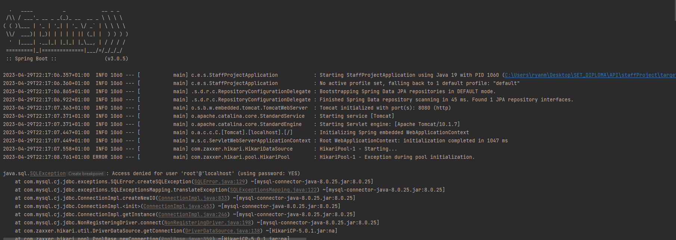

Figure : This is the first exception I came across it was thrown during the spring boot application start up for the staff API. The exception was SQL Exception denying access to the SQL server I was trying to connect to in order to connect to the management database.

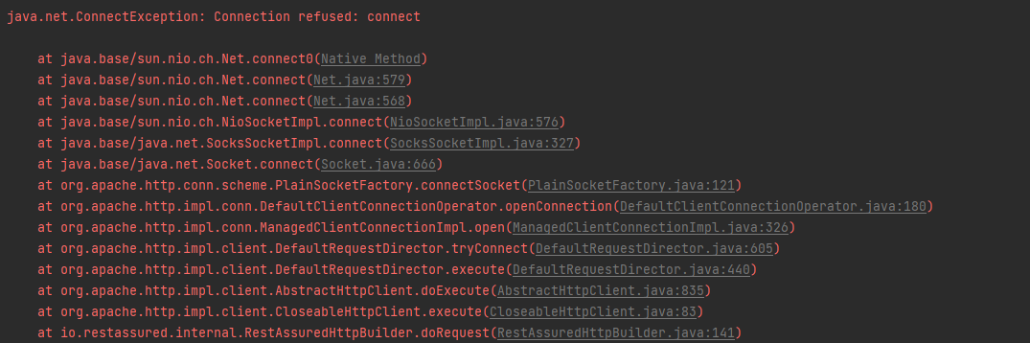Connection exception:

Figure : This issue was fixed by adding additional properties to the applications. Properties files which included the spring.datasource.password = {root password}. This fixed the issue.

Figure : I encountered another exception while working on my Spring Boot application. This occurred when I attempted to run tests without activating the Spring Boot application. The fix for this was simple: I just had to start the application before running the tests.

Assertion exception

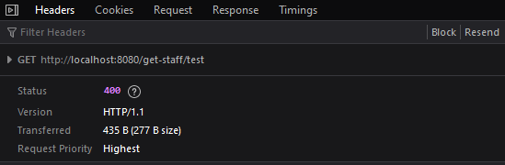

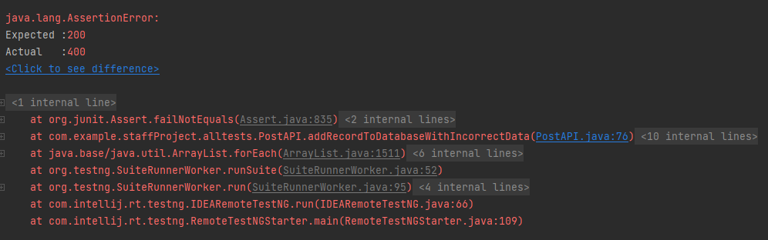

Figure : During testing of the 'get-staff/{ID}' endpoint, I encountered an exception due to accidentally entering an invalid endpoint containing text instead of an ID. As a result, the server responded with a 400-status code, indicating a bad request client error status response code due to invalid syntax in the request.

To fix this issue, I simply needed to modify the endpoint's path variable to contain an integer value instead of a string value.

404 not found error

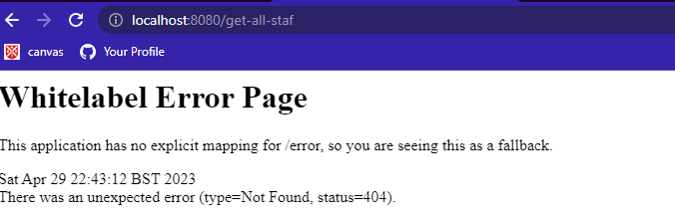

Figure : The screenshot above shows an error I encountered while trying to use an endpoint, resulting in a 404-status code being returned. This is one of the most common status codes, indicating that the requested webpage or resource could not be found on the server. The reason for this error was that I had mistyped the endpoint part of the URL, causing it to not be mapped in the Spring Boot application. To fix this, I simply corrected the spelling of the endpoint I had entered.

Server-side error

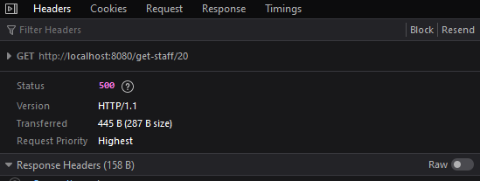

Figure : The screenshot above shows an example of another exception that occurred while working on this project. In this case, the server returned a 500-status code, which is a common server error response code. This status code indicates that the server encountered an unexpected condition that prevented it from fulfilling the client's request.

The cause of this exception was the path variable used for the endpoint. I tried to access an ID of 20, which does not exist in the staff table on the server. This resulted in the server being unable to fulfil my request and returning a 500-status code.

**AC 5.3:** Use an appropriate test strategy to effectively manage and interact with a new tab or window.

Below is an example of a test I did on a popup window on a webpage. In this test I used selenium to interact with that popup opening it up ensuring that it was the correct one

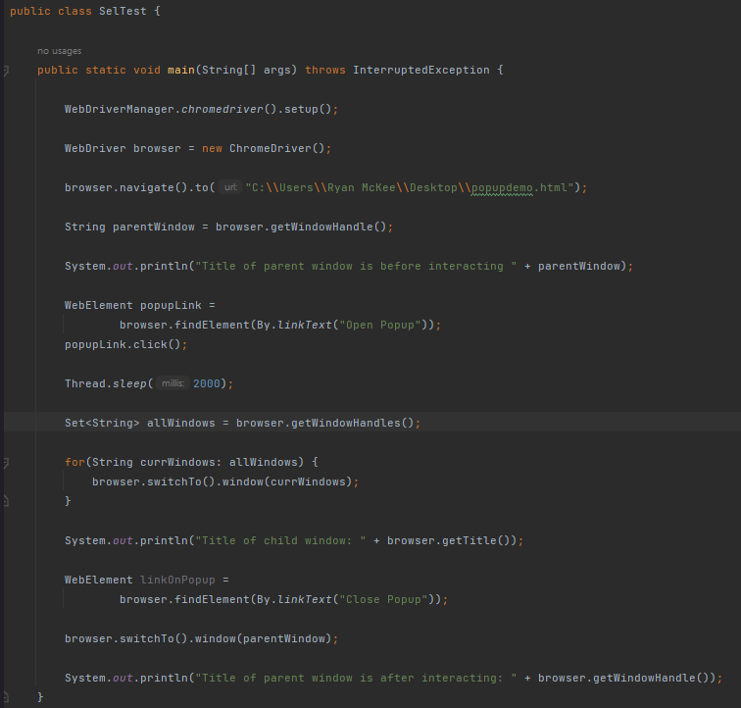

Figure : The example above depicts a Selenium test used to verify the functionality of the popup in the popupdemo.html file. The test begins by printing the title of the parent window, then utilizes the linkText locator to click the "open popup" button. Following that, the test prints out the header of the child window, closes the window using the "close popup" button using the locator, and prints out the title of the window once again.

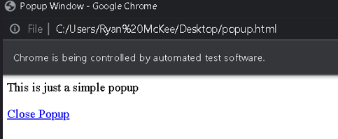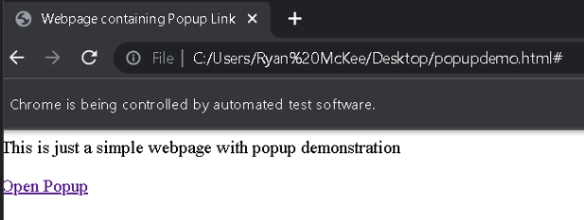

Figure : Selenium automatically opened the parent window and displayed the corresponding tab. Upon clicking the button, it opened the child window, i.e., the popup.

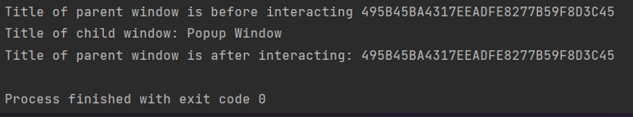

Figure : This is the final console output of the test, indicating that it was completed successfully.

Figure : This is the child window that Selenium opened. After printing out the child window header, it closed the popup using the "close popup" button.

**Section 6**

**AC 6.1:** Research and evaluate the advantages and disadvantages of implementing a test suite

In today's software development industry, the importance of testing cannot be overstated. A test suite is a collection of tests designed to test the functionality of a system or application. One of the popular testing frameworks used to implement a testing framework is TestNG, which is used for functional, unit, and integration testing. While implementing a test suite has several benefits, it also has some drawbacks that must be considered.

One of the primary benefits of implementing a test suite is that it increases the reliability of the system. A test suite ensures that all the critical functionality of the system is thoroughly tested, and the system is validated against various possible scenarios. This helps in early detection of defects, which can then be fixed before the system is deployed. This helps reduce the cost of fixing bugs later in the development cycle. Consistency is another advantage of using a test suite. Test suites ensure that the system behaves consistently across different scenarios, helping ensure that the system meets the required specifications and provides a stable user experience. Regression testing, which is essential to ensure that new features or changes do not break existing functionality, can also be performed using a test suite. This ensures that the system remains stable and consistent even after changes are made. Additionally, a test suite helps improve productivity as with a test suite in place, developers can quickly identify and fix defects, leading to increased productivity.

While implementing a test suite has several benefits, it also has some disadvantages that must be considered. One of the significant drawbacks is that it is costly to develop and maintain a test suite, especially for complex systems. This may lead to a higher development cost, which can be a significant drawback for smaller organizations or start-ups. It is also time-consuming to develop and run test suites, especially for large systems, which can lead to delays in the development cycle, which may not be acceptable in certain situations. Moreover, a test suite can give a false sense of security, leading to inadequate testing of critical functionality or failure to detect certain types of defects. Maintaining a test suite requires ongoing effort and resources, including updating tests as the system changes, fixing false positives, and addressing issues in the test environment. Finally, a test suite can only test for known scenarios, which may not cover all possible scenarios, leading to untested scenarios or unanticipated issues in the production environment.

In conclusion, implementing a test suite has several advantages, including increased reliability, early defect detection, consistency regression testing, and improved developer productivity. However, it does have some disadvantages, including cost, time consumption, false sense of security, maintenance overhead, and limited scope. Ultimately, the decision to implement a test suite should be based on the specific needs and requirements of the system being developed. While a test suite can increase the reliability of the system, it is important to weigh the benefits against the costs and potential drawbacks of implementing a test suite. Therefore, developers should carefully consider the pros and cons of implementing a test suite to determine whether it is appropriate for their specific needs.

**AC 6.2:** Create a test automation suite for use with multiple test cases for test execution purposes.

Figure 1 shows the test automation suite for the paint coverage calculation solution, which handles different coats. The project comprises two folders: "java" for implementing the project and "test" for running several tests that use the TestNG library to validate the system's functionality. It's worth noting that the package and class structure within the "test" folder reflects that of the "java" folder, which is a best practice that ensures tests are easy to maintain and locate.

In addition to the test classes, the "main" folder contains a file named "testNG.xml" that defines the test classes' hierarchy to run when performing a regression test. This file is another valuable tool for testing purposes.

By implementing a comprehensive test automation suite with well-organized and maintainable tests, the paint coverage calculation solution can be thoroughly tested and optimized for maximum efficiency and effectiveness.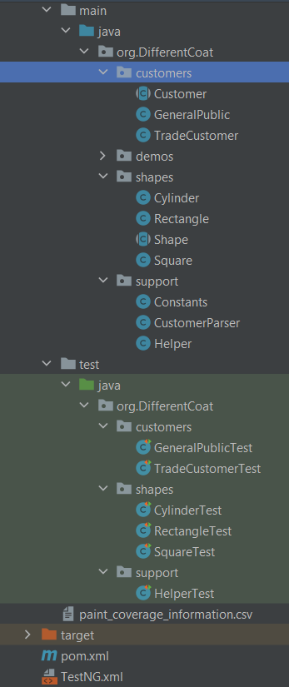

The figure below displays the contents of the TestNG.xml file, which can be a useful tool for organizing the execution order of test classes during regression testing, although it is not strictly required when using Maven. It is advisable to run the "shapes" and "support" test classes first, as they are essential dependencies for the "customer" classes to execute successfully.**Text
**

Below is an excerpt from the test suite which includes one of the test classes. This particular test class focuses on testing the rectangle class and contains four individual tests. According to the configuration set in the TestNG.xml file, this will be the third test class executed during the regression testing process.

After executing the "MVN test" command, a regression test is performed, and all the test classes within the test suite are executed. The final output of these tests is displayed in the console, as shown below.

**Section 7**

**AC 7.1:** Research and evaluate the advantages and disadvantages of using a test automation framework.

Rest Assured is a test automation framework that provides an efficient and effective way to automate API testing. Like any test automation framework, Rest Assured offers numerous benefits, including code reusability, scalability, consistency, accuracy, and faster feedback. These advantages can significantly improve the efficiency and effectiveness of testing, making it an essential tool for software development teams looking to optimize their testing processes.

One of the most significant advantages of Rest Assured is code reusability. This feature allows development teams to reduce the effort required to write and maintain test cases, resulting in faster test case development and execution. Additionally, Rest Assured allows automated test cases to be easily modified and reused across multiple projects and releases, reducing the time and effort required for regression testing.

Rest Assured also offers scalability, which is critical as organizations grow and require expanded testing efforts to support multiple projects, test cases, and environments. Rest Assured can be easily scaled to accommodate these needs, allowing development teams to quickly add new test cases or make changes to existing ones.

Another advantage of Rest Assured is consistency, which is essential for complex applications that require extensive testing to ensure their functionality. Automated tests run the same way every time, providing consistent results and reducing the likelihood of errors or inconsistencies.

Automated tests using Rest Assured are less prone to errors than manual tests, making them more accurate and reliable. Automated tests follow a predefined script and are not subject to human error, resulting in more accurate and reliable test results. This helps teams identify and fix issues more quickly, improving the overall efficiency of the testing process.

Rest Assured allows for faster execution of automated tests, providing faster feedback on the quality of the API under test. This allows development teams to identify issues and address them more quickly, resulting in faster delivery times and a more efficient testing process.

However, implementing Rest Assured also comes with its share of disadvantages. For example, setting up Rest Assured can be time-consuming and require significant resources. The framework must be configured correctly, and the tests must be designed to work with the framework, resulting in delays in the testing process and increased costs.

Rest Assured also requires ongoing maintenance to ensure that it remains up to date and continues to work correctly. This includes updating scripts to reflect changes in the API under test and addressing issues that arise during testing. Additionally, Rest Assured can be expensive to implement, particularly for small organizations with limited resources, resulting in a higher upfront cost for testing, which may be difficult to justify for organizations with limited budgets.

Automated tests using Rest Assured are not always suitable for all types of testing, particularly those that require subjective analysis or user interaction, limiting the effectiveness of automated testing in certain scenarios and requiring additional manual testing.

Finally, automated testing using Rest Assured can provide a false sense of security if it is not properly designed and executed, resulting in inaccurate test results.

In conclusion, Rest Assured offers significant benefits, including increased reusability, scalability, consistency, accuracy, and faster feedback. However, it also comes with drawbacks, such as the initial setup time, ongoing maintenance, cost, limited scope, and the potential for a false sense of security. Organizations considering implementing Rest Assured should carefully evaluate these advantages and disadvantages to determine whether it is the right choice for their specific needs and circumstances. A well-designed and properly executed Rest Assured framework can significantly improve the efficiency and effectiveness of API testing, resulting in faster delivery times and higher-quality software.

**AC 7.2:** Create a basic test automation framework for a given application that features reusability of code and low-cost maintenance

I have designed and implemented a comprehensive test automation framework for the staff API, and I would like to share the details with you. The accompanying screenshots illustrate the framework in action, and the figure below displays the project structure of the test suite.

The test suite consists of three primary packages: "apiTestMethods," "helper," and "all-tests." The "apiTestMethods" package contains reusable functions that set the request content types and Uri for the tests, as well as the expected status code content type and response time for responses. The "helper" package contains enumerations for common status codes returned. The "all-tests" package comprises four classes, each with tests for a specific request type (POST, PUT, GET, and DELETE). Collectively, these classes cover all five of the API's endpoints: get-all-staff, get-staff/{ID}, delete-staff-member/{ID}, update-staff/{id}, and add-new-staff-member.

I have employed the data-driven testing method of software testing, which involves using different types of data to test various scenarios of a software application, allowing for efficient and comprehensive test cases that cover multiple scenarios in a single test case. This is accomplished using testNG parameterized testing.

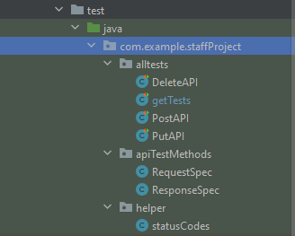To create a cost-effective and reusable test suite, I utilized several test frameworks, including rest Assured for the API testing, Ham crest for matchers, testNG which is the testing framework, and Gson to convert POJO (Plain old java objects) to JSON objects which can be sent as request body to the server and stored in the SQL database. This automation framework will allow for efficient and low-cost maintenance of the staffAPI by enabling automated testing and regression testing. The screenshots that example show examples of the methods I have employed for testing the staff API to create a useful test suite.

Figure : Above shows the project structure of the API testing suite consists of three packages: "all Tests," "apiTestMethods," and "helper." The "all Tests" package contains test classes, while the "apiTestMethods" package contains helper functions for test development and maintenance. The "helper" package includes a status codes class that defines common status codes returned by the API. This structure enhances the organization and maintainability of the testing suite, enabling developers to efficiently identify and resolve issues in the API.

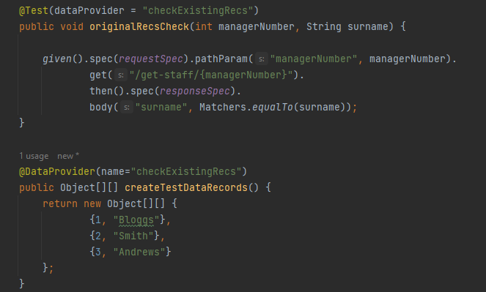

Figure : The figure displayed depicts an example of a test within the "getTests" class. This test utilizes data-driven testing through TestNG's parameterized tests, allowing it to verify three different scenarios and ensure their proper functionality. Additionally, the test class utilizes request and response specification objects. These objects are defined as fields within the PostAPI test class and are imported for use in the "getTests" class. By utilizing these objects, this test class can achieve greater efficiency and avoid code duplication.

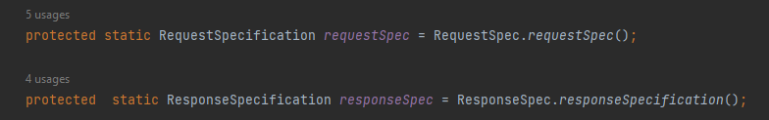

Figure : This figure shows the requestSpec object definition in the getTests fields



Figure : These are the field imports that allow the request and response specification objects to be utilized within the "getTests" class.

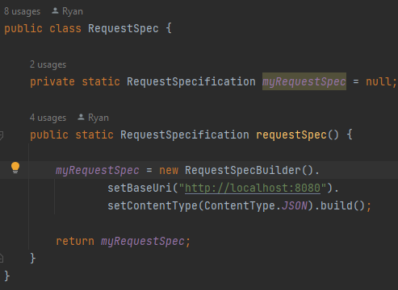RequestSpec is initialized with the RequestSpecification value returned from the function call in the RequestSpec class this is shown in screenshot below:

Figure : The RequestSpec class includes a single function that returns a RequestSpecification object with the BaseUri and content type for the staff API being tested. Consolidating this code reduces redundancy and makes it easier to modify the request specification, simplifying future maintenance.

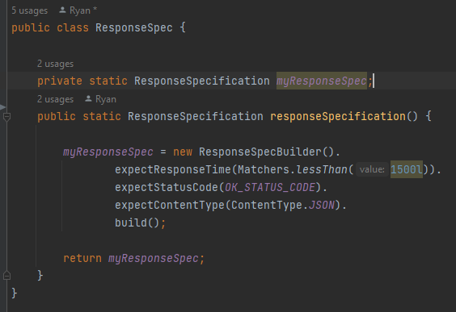

Figure : 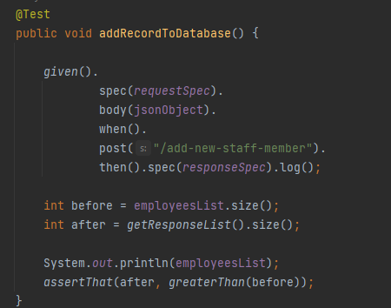The ResponseSpec class contains a single function that returns a Response Specification object. This object includes expected response header information, including a content type of less than 1.5 seconds, checked using Ham crest matchers. Additionally, the object includes an okay status code (200) and an expected JSON format for the returned content type.

Figure : shows the use of the requestSpec and response.

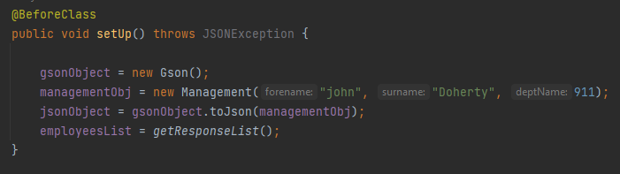

Figure : This example demonstrates how a Gson object is used to convert a POJO into a JSON object, which can be utilized in the response body for certain PostAPI tests. The subsequent example showcases a test that employs this JSON object

To run regression tests, a TestNG.xml file was created. This XML file is utilized by TestNG to configure and run test suites. The purpose of this file is to specify the test classes, the test methods to be executed, the order of execution, and other related test configurations, such as test parameters, test groups, listeners, and reporting options.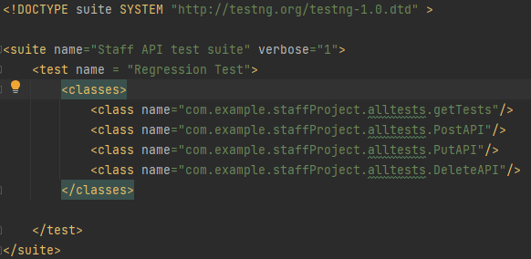

Figure : Shows the testNG.xml file and the order of execution in the classes configuration for the test order.

When the TestNG.xml file is executed, a total of 14 tests are run across the 4 assigned classes, in the order specified within the XML file.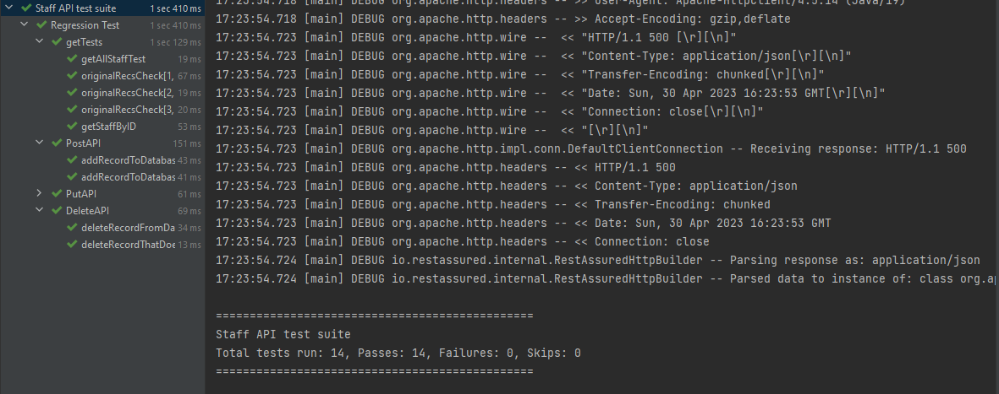

Figure : This is the final output of that xml file being run. On the left All the test statuses and response times for those tests are shown and on the right side the console shows details about how many tests were ran and how many passed.